8. Scenario: You are a data scientist working for a company that sells products online. You have

been tasked with analyzing the sales data for the past month. The data is stored in a Pandas data

frame.

Question: How would you find the top 5 products that have been sold the most in the past month?

CODE:

import pandas as pd

file_path = r"C:\Users\Shashankbheemavarapu\Downloads\sales_data.csv"

sales_data = pd.read_csv(file_path)

top_products = (

sales_data.groupby("Product_Name")["Quantity_Sold"]

.sum()

.sort_values(ascending=False)

.head(5)

)

print("Top 5 products sold:")

print(top_products)

OUTPUT:

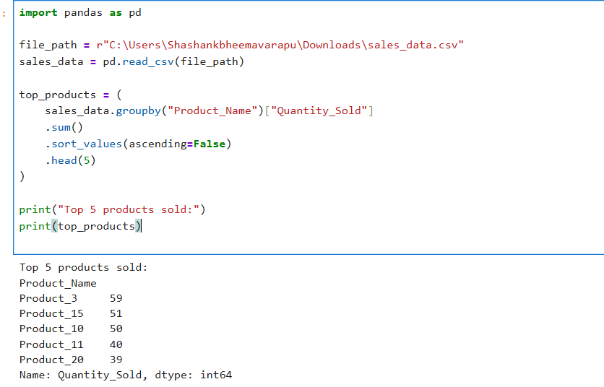

DATASET:

|  |  |  |  |  |
| --- | --- | --- | --- | --- |
| Product_ID | Product_Name | Quantity_Sold | Sale_Date | |
| P20 | Product_18 | 8 | ######## |  |
| P20 | Product_4 | 10 | ######## |  |
| P18 | Product_11 | 10 | ######## |  |
| P1 | Product_20 | 4 | ######## |  |
| P17 | Product_20 | 10 | ######## |  |
| P11 | Product_6 | 9 | ######## |  |
| P18 | Product_7 | 8 | ######## |  |
| P10 | Product_5 | 1 | ######## |  |
| P12 | Product_5 | 5 | ######## |  |
| P11 | Product_4 | 6 | ######## |  |
| P6 | Product_15 | 9 | ######## |  |
| P8 | Product_17 | 4 | ######## |  |
| P15 | Product_10 | 5 | ######## |  |
| P10 | Product_10 | 8 | ######## |  |
| P10 | Product_9 | 2 | ######## |  |
| P3 | Product_11 | 9 | ######## |  |
| P12 | Product_12 | 3 | ######## |  |
| P3 | Product_4 | 5 | ######## |  |
| P12 | Product_11 | 3 | ######## |  |
| P16 | Product_2 | 5 | ######## |  |
| P20 | Product_15 | 10 | ######## |  |
| P12 | Product_20 | 4 | ######## |  |
| P16 | Product_15 | 5 | ######## |  |
| P12 | Product_4 | 1 | ######## |  |
| P18 | Product_2 | 2 | ######## |  |
| P4 | Product_9 | 4 | ######## |  |
| P6 | Product_10 | 9 | ######## |  |
| P19 | Product_12 | 8 | ######## |  |
| P1 | Product_10 | 5 | ######## |  |
| P15 | Product_6 | 10 | ######## |  |
| P19 | Product_4 | 5 | ######## |  |
| P13 | Product_16 | 4 | ######## |  |
| P4 | Product_7 | 10 | ######## |  |
| P9 | Product_8 | 9 | ######## |  |
| P1 | Product_6 | 3 | ######## |  |
| P3 | Product_15 | 9 | ######## |  |
| P4 | Product_9 | 3 | ######## |  |
| P2 | Product_2 | 7 | ######## |  |
| P13 | Product_9 | 4 | ######## |  |
| P3 | Product_4 | 3 | ######## |  |
| P2 | Product_3 | 6 | ######## |  |
| P13 | Product_5 | 3 | ######## |  |
| P1 | Product_14 | 10 | ######## |  |
| P10 | Product_16 | 5 | ######## |  |
| P17 | Product_17 | 6 | ######## |  |
| P6 | Product_5 | 1 | ######## |  |
| P8 | Product_12 | 7 | ######## |  |
| P17 | Product_9 | 4 | ######## |  |
| P19 | Product_12 | 2 | ######## |  |
| P7 | Product_17 | 6 | ######## |  |
| P14 | Product_3 | 9 | ######## |  |
| P1 | Product_15 | 10 | ######## |  |
| P11 | Product_19 | 7 | ######## |  |
| P10 | Product_10 | 10 | ######## |  |
| P13 | Product_3 | 3 | ######## |  |
| P5 | Product_3 | 10 | ######## |  |
| P19 | Product_9 | 1 | ######## |  |
| P12 | Product_6 | 9 | ######## |  |
| P19 | Product_15 | 8 | ######## |  |
| P9 | Product_3 | 1 | ######## |  |
| P19 | Product_1 | 8 | ######## |  |
| P7 | Product_14 | 1 | ######## |  |
| P8 | Product_19 | 5 | ######## |  |
| P14 | Product_14 | 7 | ######## |  |
| P4 | Product_10 | 3 | ######## |  |
| P11 | Product_11 | 4 | ######## |  |
| P11 | Product_1 | 10 | ######## |  |
| P2 | Product_13 | 6 | ######## |  |
| P20 | Product_12 | 4 | ######## |  |
| P20 | Product_9 | 9 | ######## |  |
| P8 | Product_3 | 4 | ######## |  |
| P3 | Product_3 | 7 | ######## |  |
| P7 | Product_20 | 9 | ######## |  |
| P6 | Product_11 | 3 | ######## |  |
| P8 | Product_10 | 9 | ######## |  |
| P5 | Product_8 | 4 | ######## |  |
| P19 | Product_16 | 8 | ######## |  |
| P8 | Product_5 | 1 | ######## |  |
| P13 | Product_3 | 10 | ######## |  |
| P13 | Product_18 | 1 | ######## |  |
| P15 | Product_3 | 6 | ######## |  |
| P4 | Product_20 | 4 | ######## |  |
| P7 | Product_3 | 3 | ######## |  |
| P13 | Product_10 | 1 | ######## |  |
| P1 | Product_17 | 2 | ######## |  |
| P5 | Product_20 | 4 | ######## |  |
| P2 | Product_19 | 1 | ######## |  |
| P5 | Product_20 | 2 | ######## |  |
| P5 | Product_11 | 7 | ######## |  |
| P18 | Product_11 | 4 | ######## |  |
| P8 | Product_8 | 2 | ######## |  |
| P13 | Product_16 | 9 | ######## |  |
| P6 | Product_4 | 4 | ######## |  |
| P10 | Product_6 | 6 | ######## |  |
| P5 | Product_8 | 9 | ######## |  |
| P14 | Product_20 | 2 | ######## |  |
| P17 | Product_6 | 2 | ######## |  |
| P16 | Product_18 | 2 | ######## |  |
| P9 | Product_7 | 7 | ######## |  |
| P17 | Product_19 | 9 | ######## |  |